  Workfront to CTT integration  1.0 | High Level summary  Document the business requirements for a Proof of Concept to integrate Workfront and the Campaign Tagging and Tracking (CTT) tool as an interim compatibility layer during the transition to Workfront and Adobe North Star.  Amanda Pattenden  Digital Marketing Manager

Revision History
Date | Version | Description | Author
08/07/0226 | 1.0 | Initial Draft | Amanda Pattenden

Table of Contents

1. Introduction 4
Executive Summary 4
Problem Statement – Why? 4
Vision – What? 4
Benefit Summary – Who? 5
2. Scope and Limitations 6
In-Scope 6
Out of Scope 6
Assumptions 7
Dependencies 7
Success Metrics 8
3. Business Process 8
Business Process – As Is (Current State) 8
Business Process – To Be (Future State) 9
4. Summary of Impacts 9
5. Stakeholder Requirements 10
Stakeholders 10
Campaign Tagging & Tracking Tool 10
Campaign Tagging & Tracking Request Portal 12
Workfront 12
Salesforce 13
Eloqua 14
CDF 14
OMS 14
Enriched Requirements 14
6. Appendix 0
Appendix 1 0
Appendix 2 0
Appendix 3 1
Appendix 4 1
Appendix 5 2
Appendix 6 2
Appendix 7 0
7. Glossary of Terms 0
Glossary 0
8. Approvals and Sign-Off 0
Document Reviewers 0

- Introduction

Executive Summary
The objective of this initiative is to align our campaign tracking capabilities with FY27 reporting requirements while supporting the transition toward Workfront as our primary platform for marketing work management, execution, and data governance.

The ideal state is to establish and validate an interim integration between Workfront and the Campaign Tagging and Tracking (CTT) tool that automatically generates Activity and Offer IDs and synchronizes required FY27 reporting attributes directly within the Workfront workflow.

However, if this automated integration is not prioritized for immediate technical execution, the core requirement remains: we must update the CTT tool and the CTT Request Portal with the new FY27 data fields, hierarchies, and standardized picklists. Updating these fields directly in the CTT ecosystem ensures that, at a minimum, marketing teams can achieve manual data alignment across Workfront-managed and non-Workfront activities.

This dual-path approach guarantees consistent data capture, protects downstream reporting and attribution continuity, and maintains data quality across enterprise systems regardless of integration timelines.

Problem Statement – Why?
Adobe Workfront is the strategic platform for marketing work management, execution, and data governance. However, the Campaign Tagging and Tracking (CTT) tool remains a critical component of the current marketing ecosystem, providing campaign identifiers, metadata enrichment, routing, attribution, and reporting capabilities that are still required by multiple downstream systems and measurement processes.

While Workfront adoption is increasing, not all marketing activities currently originate in or flow through Workfront. In addition, key reporting and attribution processes continue to rely on CTT-generated identifiers—including Activity ID, Offer ID, Drive To ID, and OCIDs—and planned Salesforce changes are limited by dependencies on the One Cisco CRM (OCC) program. As a result, the organization cannot yet fully retire CTT or transition to a Workfront-only reporting model without introducing significant operational and measurement risk.

Marketing has established a set of FY27 reporting requirements, including the consistent capture of Business Priority, Stakeholder Unit, campaign hierarchy, and program context across all marketing activities. Without an integration between Workfront and CTT, these data elements will be captured inconsistently across systems, creating reporting gaps, reducing data quality, and limiting the organization's ability to accurately measure marketing performance and attribution.

An interim integration is therefore required to bridge Workfront and CTT during the transition period. This solution will enable consistent data capture and governance across all marketing activities, preserve downstream reporting and attribution processes that depend on legacy identifiers, and support continued Workfront adoption without disrupting existing business-critical measurement capabilities.

Vision – What?
The objective of this initiative is to align our campaign tracking capabilities with FY27 reporting standards and deliver a focused Proof of Concept (POC) that integrates Adobe Workfront with the Campaign Tagging and Tracking (CTT) tool. This provides a controlled transitional solution as Cisco moves toward Workfront as the primary platform for marketing execution, reporting, and data governance.

Primary Objective: Workfront & CTT Integration POC
The POC will validate the ability for Workfront-originated marketing activities to leverage CTT capabilities where legacy dependencies still exist. Specifically, the ideal state integration will:
- Automate Identifier Creation: Automatically generate Activity IDs for channel activations and Offer IDs for content activations initiated through Workfront.
- Synchronize Data Attributes: Synchronize generated identifiers and required FY27 reporting attributes between CTT and Workfront.
- Ensure Consistent Data Governance: Ensure consistent capture and governance of key reporting data elements across Workfront-managed activities, CTT-managed activities, and activities that originate outside Workfront.
- Preserve Reporting Continuity: Maintain continuity for downstream reporting, attribution, and measurement processes that currently depend on CTT identifiers.
- Simplify Marketing Workflows: Reduce reliance on marketers to understand, request, and correctly configure campaign tracking identifiers by embedding ID creation directly into the Workfront workflow.

By establishing this integration, the organization can accelerate Workfront adoption while preserving existing business-critical reporting and attribution capabilities. The POC will also validate the approach for maintaining data consistency and measurement integrity during the transition period, reducing the risk associated with moving away from legacy CTT dependencies.

Fallback Baseline: Direct CTT & CTT Request Portal Schema Updates
If technical or prioritization constraints prevent the immediate delivery of the automated integration, the secondary objective is to update the CTT tool and CTT Request Portal directly with all agreed FY27 fields, hierarchies, and picklists. This ensures that even in the absence of an automated integration, marketing teams can achieve manual data alignment and capture complete FY27 reporting attributes across all activations.
Strategic Alignment
This solution is intended as a temporary compatibility layer—not a long-term architecture. Its purpose is to bridge current-state dependencies while enabling progress toward the future-state Adobe North Star architecture and the eventual decommissioning of CTT, with defined exit criteria and a clear migration path.

Benefit Summary – Who?
The Workfront & CTT Integration POC benefits anyone relying on marketing data for FY27 reporting, analysis, or strategic decision-making, as well as the teams responsible for Workfront adoption.

- Marketing Teams: Automated creation of Activity and Offer IDs removes the need for marketers to understand, request, and manage tracking IDs, reducing effort, errors, and process complexity.
- Marketing Analytics & Insights Teams: Consistent FY27 reporting attributes across all marketing activities improve data quality, performance analysis, and measurement of strategic priorities.
- Reporting & Attribution Teams: Preserves access to the CTT identifiers and metadata required for attribution, funnel reporting, and downstream measurement processes, ensuring reporting continuity.
- Workfront Adoption Teams: Reduces adoption friction by enabling teams to work in Workfront without worrying about manual ID management or impacts to campaign measurement.
- Technology, Data Governance & Architecture Teams: Validates the integration approach, identifies remaining CTT dependencies, and provides a clear roadmap toward Adobe North Star alignment and eventual CTT decommissioning.
- CRM / One Cisco CRM (OCC) Teams: Allows marketing tracking modernization to progress without requiring immediate Salesforce tracking parameter changes while OCC initiatives are underway.

- Scope and Limitations

In-Scope
The scope includes:

- Definition of the FY27 reporting attributes required within Workfront and identification of corresponding CTT fields required during the transition period.
- Documentation of the relationship and mapping between Workfront Task ID, Activity ID, Offer ID, Drive To ID, and UTM_ID.
- Automated creation of Activity IDs for selected Workfront channel activations.
- Automated creation of Offer IDs for selected Workfront content activations.
- Synchronization of generated IDs and agreed FY27 reporting attributes between CTT and Workfront.
- Addition of key FY27 reporting attributes (e.g., Business Priority, Stakeholder Unit) within CTT to ensure consistent data capture across Workfront and non-Workfront activities—ensuring manual data alignment is possible even if automated integration is delayed.
- Updates to the CTT Request Tool to support the capture of FY27 reporting attributes across Create New, Create Bulk, and Update Existing workflows for teams not yet utilizing Workfront.
- Integration and alignment of the latest Finance-approved Business Entity (BE) master list within the CTT Offer ID configuration.
- Removal of the legacy Vertical Market field from the CTT Offer ID schema and associated Request Portal workflows.

This scope is intentionally limited to proving the viability of the integration, validating reporting outcomes, reducing manual tracking ID administration, and informing future decisions regarding broader rollout and eventual CTT decommissioning.

Out of Scope
The following items are explicitly excluded from this Proof of Concept (POC):

- Full decommissioning of the Campaign Tagging and Tracking (CTT) tool and retirement of its integrations, which will be addressed through a separate CTT decommissioning initiative.
- Changes to Salesforce tracking parameters, data structures, or One Cisco CRM (OCC) configurations.
- Enterprise-wide Workfront adoption, process transformation, or changes to project, task, resource, or budget management practices beyond the pilot use case.
- Migration, remediation, or transformation of historical campaign tracking data, including legacy CCIDs, DTIDs, OIDs, or existing OCID records.
- Replacement, upgrade, or replatforming of connected enterprise systems such as Eloqua, Salesforce, Allocadia, or other marketing technology platforms.
- Resolution of all identified CTT dependencies; the POC will document, assess, and prioritize remaining dependencies rather than deliver full remediation.
- Enterprise-wide cleanup, correction, or re-tagging of legacy tracking IDs across existing websites, landing pages, forms, or digital assets.
- Redesign of marketing attribution methodologies, reporting frameworks, or measurement models beyond validating continuity of existing reporting capabilities.

This POC is focused solely on validating the Workfront–CTT integration approach, automating tracking ID creation, enabling consistent FY27 data capture, and generating the evidence required to support future scaling and eventual CTT decommissioning.

Assumptions
The successful delivery of this project and the accuracy of downstream reporting are based on the following assumptions:

- The FY27 reporting attributes (e.g., Business Priority, Stakeholder Unit, Program Context) have been defined and are sufficiently stable to support design, configuration, and testing.
- If the direct integration between Workfront and CTT is not prioritized for immediate implementation, configuration updates to the CTT tool and CTT Request Portal will proceed independently to ensure all required FY27 data elements are captured for new attribution models.
- Workfront Task IDs are available for the selected pilot use cases and can be used as the primary reference identifier within the integration.
- The CTT platform can be configured to store and manage additional FY27 reporting attributes required during the transition period.
- A defined channel and/or content activation type with manageable Workfront, CTT, and downstream dependencies is available for the POC.
- Subject matter experts and technical resources from Workfront, CTT, Integration, Reporting, and Marketing Operations teams will be available and prioritized throughout the project lifecycle.
- Workfront will continue to be the long-term system of record for marketing execution, workflow management, and reporting data governance.
- The integration is intended solely to support the transition period; CTT remains on the planned decommission path with agreed exit criteria.
- Delivery of the project can be achieved without modifications to Salesforce tracking parameters, Salesforce data structures, or One Cisco CRM (OCC) configurations.
- Current reporting, attribution, and measurement processes that consume CTT identifiers will continue to function throughout the transition period.
- Findings, lessons learned, and identified dependencies from the POC will be used to inform future rollout decisions and the broader CTT decommissioning strategy, but will not replace that initiative.
- Data mapping between Workfront and CTT fields is based directly on definitions, structures, and metadata extracted from the Workfront Admin report and the CTT Data Dictionary.

Dependencies
Successful execution and data alignment rely on the following key dependencies across technical platforms, business governance, and project resourcing:

- Final approval and sign-off on FY27 reporting attributes, field mappings, business rules, picklists, and success criteria across all reporting and attribution stakeholders.
- Timely deployment of schema updates, new FY27 bridge/attribute fields, and updated picklists within the core CTT database to enable manual and automated data capture for new attribution models to be defined
- Deployment of updated form schemas, field picklists, and updated bulk templates across Create New, Create Bulk, and Update Existing workflows within the CTT Request Portal.
- Configuration of pilot custom fields, Task ID references, and automated write-back trigger attributes within the Workfront environment (Conditional on Integration Prioritization)
- Availability of endpoint connectivity and mapping logic to support automated ID generation and bidirectional attribute synchronization between Workfront and CTT.
- Availability of test environments, staging databases, and baseline datasets to validate data ingestion into downstream FY27 attribution models.
- Complete inventory of existing downstream dependencies (dashboards, attribution engines, downstream systems) to inform field design and long-term decommission planning.
- Dedicated technical, governance, and business analyst resources assigned across Workfront, CTT/Integration, Marketing Operations, and Reporting teams.
- Defined ownership and stewardship agreements for shared reporting attributes across enterprise data teams.
- Leadership alignment, funding confirmation, and clear decision-making authority established across both the interim CTT capability enhancements and the broader CTT decommissioning strategy.

Success Metrics
- Data Quality: ≥95% completeness for generated IDs and agreed FY27 reporting attributes written back to Workfront.
- Reporting Consistency: Workfront-originated and non-Workfront activities can be reported using the same FY27 data elements in validated reporting outputs.
- User Experience: Pilot users can create, request, or approve activations without additional manual tracking ID administration.
- Workfront Adoption Enablement: Reduced dependency on marketers' knowledge of CTT tracking processes and ID management.
- Decommission Readiness: A prioritized backlog of CTT dependencies, retirement activities, and recommended next steps is produced.
- CRM Independence: Marketing tracking modernization progresses without requiring immediate Salesforce or One Cisco CRM changes.
- Decision-Making Outcome: A formal recommendation to scale, pause, or stop the initiative is delivered, supported by findings, risks, and a next-phase roadmap.

- Business Process

Business Process – As Is (Current State)
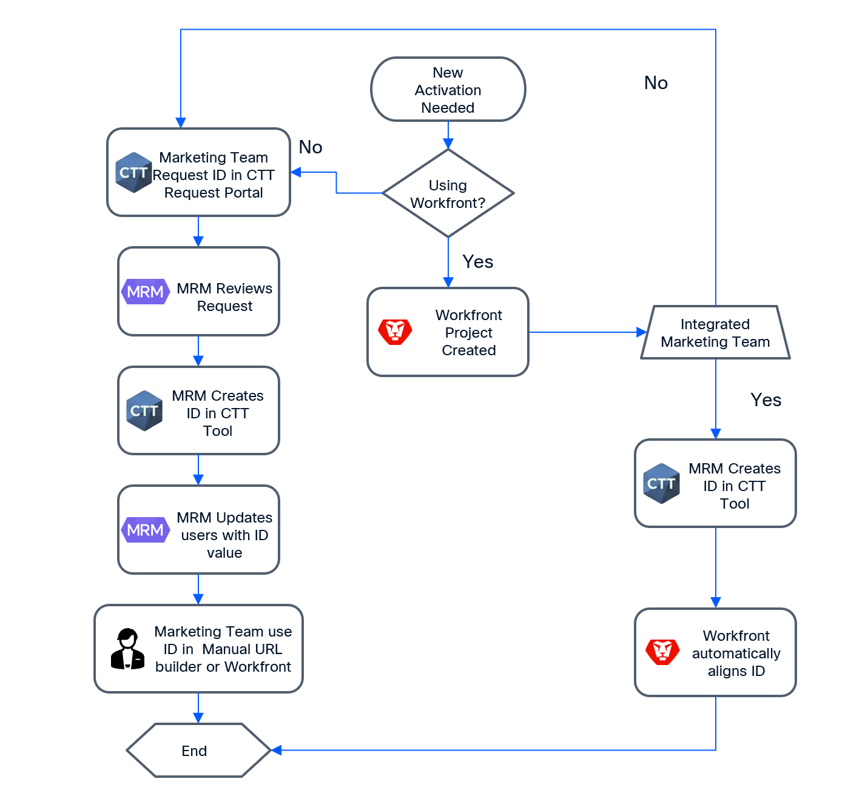

Business Process – To Be (Future State)
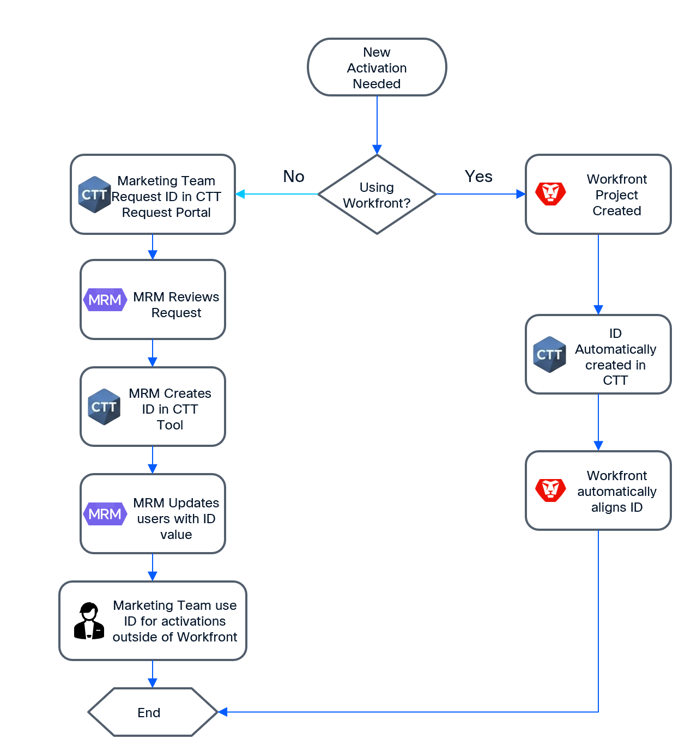

- Summary of Impacts

Tool | Summary | CTT Direct Integration or Aligning Process
Workfront | Configure pilot fields; trigger CTT ID creation; receive write-back of IDs | Integration
CTT Activity ID | Rename Business Unit to Stakeholder Unit; remove Buying Centre linkage; add Primary Technology, Funnel Stage; update Campaign/Program hierarchy | Process
CTT Offer ID | Add Technology/Campaign/Program alignment; standardize Offer Type list | Process
CTT Request Portal | Update Stakeholder Group, Technology/Campaign/Program, Funnel Stage, Offer Type across request, edit, update existing, and bulk upload workflows | Process
OMS Tables | Publish all new CTT field values for reporting consumption, deprecate and stop ingestion of the Vertical Market field from the CTT Offer ID schema. | Integration
Marketing Reporting | Define FY27 data elements; build pilot dataset and sample report. Audit and remove the Vertical Market and Buying Centre dimension from the pilot FY27 dataset and sample reports. | Process
Salesforce | No changes during POC; existing ID campaign alignment continues | No Change
Eloqua | No changes during POC | No Change
Allocadia | Excluded from new CTT field API exposure during bridge | No Change
Non-Workfront Teams | Continue using updated CTT Request Portal with aligned FY27 attributes | Process

- Stakeholder Requirements

Stakeholders
Stakeholder | Code | Description
GTM Readiness & Performance | CTT | Changes to CTT tool owned by GTMR&P team
GTM Readiness & Performance | POR | Changes to the CTT Request Portal
PEDS | WFT | Changes to Workfront

Campaign Tagging & Tracking Tool
General Overview

CTT001: As a CTT Administrator, I want CTT configured with interim bridge fields to carry Workfront-aligned FY27 data attributes, so that non-Workfront teams can use IDs with the same reporting data elements during transition full list can found in Table 1 - ID Field List

CTT002: As a CTT Administrator, I want Workfront-originated activation requests to automatically create Activity IDs for channel activations, so that the ID creation process is triggered without manual CTT Request Tool submission.

CTT003: As a CTT Administrator, I want Workfront-originated activation requests to automatically create Offer IDs for content activations, so that offer tracking remains consistent with current CTT operations.

CTT004: As a CTT Administrator, I want existing CTT-dependent processes to continue functioning during the pilot, so that business continuity is protected while the bridge is validated.
Activity IDs - Additions

CTT005: As a Marketing Manager, I want a Funnel Stage field added to Activity ID so that marketing activities are tagged to the correct funnel position for FY27 reporting and attribution that can be found in Table 4 - Funnel Stage
Activity IDs – Amend

CTT006: As a Data Governance Lead, I want the Activity ID field "Business Unit" renamed to "Stakeholder Unit" with a standardized list of values found in so that FY27 reporting uses consistent stakeholder attribution across all activities that can be found in Table 2 - Stakeholder List

CTT007: As a Marketing Manager, I want to select a Primary Technology when creating an Activity ID so that only the relevant campaigns and associated programs are available for selection, enabling accurate alignment of my channel activation to the correct technology, campaign, and program based on the approved Technology > Campaign > Program mapping defined Table 3 - Technology > Campaign > Program Mapping
Activity IDs – Remove

CTT008: As a Marketing Manager, I want the linkage between Campaign and Buying Centre removed from the Activity ID UI, so that I can select campaigns and programs from a distinct list without unnecessary buying centre constraints as depicted in Table 3 - Technology > Campaign > Program Mapping
Offer IDs - Additions

CTT009: As a Marketing Manager, I want new Technology, Campaign, and Program fields added to Offer ID, aligned to the same hierarchy and selection logic used on Activity ID, so that content activations capture consistent campaign hierarchy attributes and can be accurately reported against the approved Technology → Campaign → Program mapping defined in
Table 3 - Technology > Campaign > Program Mapping

CTT010: As a Marketing Manager, I want a new Stakeholder Group field added to Offer ID, with selectable values aligned to the approved stakeholder hierarchy defined in Table 2 - Stakeholder List, so that content activations can be associated with the correct audience and reported consistently across marketing activities.

CTT011: As a Marketing Manager, I want a new Funnel Stage field added to Offer ID, with selectable values aligned to the approved Funnel Stage framework defined Table 4 - Funnel Stage, so that content activations can be consistently classified according to their role in the customer journey and measured appropriately.
Offer IDs - Amends

CTT012: As a Marketing Manager, I want the Offer Type field updated to a standardized list of values organized by Offer Category (e.g., Collateral, Gated, and All Else), with available Offer Types mapped according to the approved Offer Category → Offer Type hierarchy defined in Table 5 - Offer Category > Offer Type so that offer classification is applied consistently across all content activations and supports standardized reporting and analysis.

CTT013: As a CTT Administrator, I want the Business Entity field updated with the latest master list from Finance, so that all content activations are accurately mapped to current corporate financial structures that is defined in Table 6 - Business and Sub Business Entity
Offer IDs – Remove

CTT014: As a Data Engineer, I want the Vertical Market field deprecated from the Offer ID ingestion pipeline to the OMS tables, so that legacy, unutilized data is not published to centralized reporting tables
Data Capture

CTT015: As a Data Engineer, I want all new and updated CTT field values published to OMS tables, so that reporting and downstream data consumers can access the updated attribute model.

CTT016: As an Integration Engineer, I want new CTT field values excluded from Tray.io, Allocadia, and SFDC API integrations during the bridge period, so that existing downstream integrations are not disrupted while CTT field changes are validated.

Campaign Tagging & Tracking Request Portal
Activity IDs
POR001: As a Marketing Manager, I want the CTT Request Portal Stakeholder Group field updated to use the same standardized values as CTT Stakeholder Unit across Create New, Create Bulk, and Update Existing Activity ID request types, so that portal submissions align with the updated stakeholder taxonomy as listed in Table 2 - Stakeholder List

POR002: As a Marketing Manager, I want the CTT Request Portal selection hierarchy changed from Buying Centre > Campaign Theme > Program to Technology > Campaign > Program across Create New, Create Bulk, and Update Existing Activity ID request types, so that the portal reflects the new campaign alignment model as listed in Table 3 - Technology > Campaign > Program Mapping

POR003: As a Marketing Manager, I want a Funnel Stage field added to Activity ID requests in the CTT Request Portal with values Awareness, Consideration, Evaluation, and Decision, across Create new, Create Bulk and Update Existing Activity ID request types, so that I can specify the funnel position when requesting new Activity IDs.

Offer IDs
POR004: As a Marketing Manager, I want the CTT Request Portal updated with the new standardized Offer Type list across Create New, Create Bulk, and Update Existing Offer ID request types, so that offer classification matches the updated CTT taxonomy as shown in Table 5 - Offer Category > Offer Type

POR005: As a Marketing Manager, I want the Business and Sub Business Entity list of values updated across Create New, Create Bulk, and Update Existing Offer ID request types, so that they reflect the standardized list of financial values shown in Table 6 - Business and Sub Business Entity

POR006: As a Marketing Manager, I want the Vertical Market field removed from Create New, Create Bulk, and Update Existing (Edit) Offer ID request types and templates, so that the submission interface remains clean and aligned with the current reporting architecture.

POR007: As a Marketing Manager, I want the Buying Centre field removed from Create New, Create Bulk, and Update Existing Offer ID request types and templates, and the logic to automatically populate the originating Activity ID removed, so that we can capture the data from the originating Activity as data elements directly within the Offer ID moving forward.

POR008: As a Marketing Manager, I want the Technology > Campaign > Program hierarchy fields added to Create New, Create Bulk, and Update Existing Offer ID request types and templates, so that we can utilize the information in content attribution modelling as listed in Table 3 - Technology > Campaign > Program Mapping

POR009: As a Marketing Manager, I want the Funnel Stage field added to Create New, Create Bulk, and Update Existing Offer ID request types and templates, so that we can allow attribution reporting for content as listed in Table 4 - Funnel Stage

Workfront
WFT001: As a Marketing Manager, I want Workfront to automatically trigger Activity ID creation in CTT when I approve a channel activation in the pilot scope using the data fields as defined in Table 7 - Activity ID mapping Workfront - CTT and have the generated Activity ID written back to the corresponding Workfront task, so that I do not need to manually request IDs through the CTT Request Tool or manually copy them back into Workfront.

WFT002: As a Marketing Manager, I want Workfront to automatically trigger Offer ID creation in CTT when I approve a content activation in the pilot scope, so that consumed offers remain traceable without manual ID administration.

WFT003: As a Workfront Administrator, I want generated Activity IDs and Offer IDs written back to Workfront as data attributes on the corresponding task/activation record, so that reporting teams can access IDs from Workfront data.

WFT004: As a Workfront Administrator, I want field edits made to agreed FY27 reporting attributes (e.g., Stakeholder Unit, Funnel Stage, campaign/program context) on a Workfront record to automatically trigger an update to the corresponding record in CTT, so that both systems remain synchronized throughout the activation lifecycle.

. Additional Workfront User Stories
WF005: Field Modification Synchronization
WF006: Integration Lock Post-Execution
As a CTT Administrator, I want Workfront to restrict or lock edits to synchronized fields once a channel or content activation goes "Live" (or after an ID has been pushed downstream to Eloqua/Salesforce), so that historical attribution data and production tracking remain stable.
WF007: Modification Error Handling
As an Integration Engineer, I want any failed field update synchronization between Workfront and CTT to trigger an automated alert to the Marketing Operations team, so that data discrepancies can be manually remediated before OMS ingestion occurs.
2. Corresponding Downstream Technical Requirements
To ensure these edits do not break validation or reporting pipelines downstream, you should also add these complementary requirements to your OMS and Reporting sections:
OMS
As a Data Engineer, I want the OMS tables to process upserts (updates/inserts) for modified CTT and Workfront records, so that the data warehouse always reflects the latest edited state of an activation's attributes.
Marketing Reporting / Data Validation
As a Reporting Analyst, I want a weekly data discrepancy report built to flag any Workfront Task IDs where the data attributes in the Workfront record do not perfectly match the data elements in the CTT record.
As a Workfront Administrator, I want agreed FY27 attributes (Business Priority, Stakeholder Unit, Funnel Stage, campaign/program context, Task ID, UTM attributes) captured on Workfront records and available for integration, so that data is consistent with the bridge-period reporting model.

As a Marketing Manager, I want to select and configure a pilot activation type with known dependencies, so that the POC validates a realistic operating scenario without enterprise-wide rollout risk.

Salesforce
SF001: As a CRM Product Owner, I want the POC to require no immediate SFDC tracking parameter changes, so that One Cisco CRM work is not disrupted during the bridge period.
SF002: As a Data Engineer, I want existing SFDC campaign alignment to Activity ID and Offer ID to continue unchanged during the pilot, so that lead creation and campaign member processes are not impacted.

Eloqua
EL001: As a Marketing Automation Specialist, I want the POC to avoid changes to Eloqua picklists, forms, or AOJ integrations during the pilot, so that existing automation continues while the Workfront-CTT bridge is validated.

CDF
CDF001: As a Reporting Analyst, I want the pilot to document how bridge-period data relates to current CDF Transaction Table dependencies, so that the decommission backlog includes CDF migration requirements.

OMS
OMS001: As a Data Engineer, I want all new CTT field values (Stakeholder Unit, Primary Technology, Funnel Stage, Technology/Campaign/Program, Offer Type) published to OMS tables, so that reporting teams can validate FY27 data elements from a centralized source.
OMS002: As a Reporting Analyst, I want OMS tables to reflect the updated CTT attribute model before pilot reporting validation begins, so that sample reports use the same data source as future-state reporting.

Enriched Requirements
The core POC ensures Workfront can trigger CTT ID creation, CTT and portal fields are aligned to FY27 standards, and reporting continuity is validated.
ER001: As a Program Manager, I want a documented decommission blocker list with owner assignments, so that leadership has a credible path to CTT retirement beyond the pilot.
ER002: As a Marketing Leader, I want a formal scale/pause/stop recommendation with decision criteria, so that investment beyond the POC is evidence-based.
ER003: As a Data Governance Lead, I want explicit exit criteria defining when CTT can be decommissioned, so that the bridge is not perceived as extending CTT life indefinitely.
ER004: As a Workfront Adoption Lead, I want pilot user feedback on operational fit (manual steps, approval workflow, ID visibility), so that scale planning addresses adoption friction.
ER005: As an Architecture Lead, I want the POC architecture assessed for scalability beyond the pilot, so that a scale decision does not require complete redesign.
ER006: As a Data Governance Lead, I want a reference data appendix documenting all Stakeholder Unit, Funnel Stage, Technology/Campaign/Program, and Offer Type
As an Architecture Lead, I want the removal of the Vertical Market field documented as a structural schema change, so that any unexpected legacy downstream dependencies outside the pilot scope are flagged during the POC evaluation.

<List out your Specific Stakeholder Requirements>

- Appendix

Appendix 1

Table 1 - ID Field List
OCID | Field Name | Description | New or Existing
Activity ID | Technology | Marketing Targetted Capmaign Technology | New
Activity ID | Funnel Stage | What stage of the funnel is this inititaive targeting | New
Activity ID | Activity Name | Free Format Text | Exsiting
Activity ID | Activity Description | Free Format Text | Exsiting
Activity ID | Activity ID | Auto generated by OCIDG Tool | Existing
Activity ID | Requested By | CEC ID of ID Requestor | Existing
Activity ID | Campaign | Reset of Values | Existing
Activity ID | Program | Reset of Values | Existing
Activity ID | Marketing Initiative | Marketing Type | Existing
Activity ID | Live Date | Start Date | Existing
Activity ID | Expiration Date | End Date | Existing
Activity ID | Partner Flag | Is this ID aligned to partner communications | Existing
Activity ID | Partner Name | Partner we are working with on this initiative | Existing
Activity ID | Region | What region is setting up the marketing initiative | Existing
Activity ID | Stakeholder Group | Name Change and list update for Business Unit | Exisitng
Offer ID | Funnel Stage | What stage of the funnel is this offer targeting | New
Offer ID | Technology | Marketing Targetted Capmaign Technology | New
Offer ID | Campaign | Campaign that this offer is aligned to | New
Offer ID | Program | Program that this offer is aligned to | New
Offer ID | Offer ID | Auto generated by OCIDG Tool | Existing
Offer ID | Offer Type | List to be redefined | Existing
Offer ID | Business Entity | Aligned to a standar list of BE values – needs to be udpated | Existing
Offer ID | Offer Name | Free format text | Existing
Offer ID | Description | Free formt text | Existing
Offer ID | Language | Predominant langugae the offer is created in | Existing
Offer ID | Live Date | Start Date | Existing
Offer ID | Exiration Date | End Date | Existing
Offer ID | Requested By | CEC ID of requestor of ID | Existing
Offer ID | Country | Primary Countries being targetted for this offer (no reporting alignment) | Existing
Offer ID | Originating Activity ID | Which Activity Does this Offer primarily align to | Existing
Offer ID | Content Creation team | Renames to Stakeholder Group and list updated | Existing
Select Alt + Left Arrow to return to your user story

Appendix 2

Table 2 - Stakeholder List
Stakeholder | Stakeholder | Stakeholder
Brand Marketing | Lifecycle Marketing - Digital | Product Marketing - Observability
Cisco Live | Lifecycle Marketing - Web Marketing | Product Marketing - Security
Communications | Lifecycle Marketing - Other | Product Marketing - Other
Integrated Marketing | One Cisco | Sales
Integrated Marketing - Media | Partner | Sponsorships
Field Marketing | Product Marketing - Collaboration | Strategic Growth
Finance | Product Marketing - Computing | Strategy Planning & Operations
Event Marketing | Product Marketing - Cross Product | Virtual Demand Center
Information Technology | Product Marketing - CX | SMB / Mid Market
Legal Operations | Product Marketing - Data Center | Other
Lifecycle Marketing - Customer Advocacy | Product Marketing - IoT | Product Marketing - Observability
Lifecycle Marketing - Customer Marketing | Product Marketing - Networking | Product Marketing - Security
Select Alt + Left Arrow to return to your user story

Appendix 3

Table 3 - Technology > Campaign > Program Mapping
Primary Technology | Campaign | Program (Campaign tracks)
Networking | No Campaign
Networking | SMB
Networking | Up Market - Modernize and Secure Network | No Campaign Tracks
Networking | Up Market - Modernize and Secure Network | Up Market - Wireless LDoS
Networking | Up Market - Modernize and Secure Network | Up Market - Launch - TQMT
Networking | Up Market - Modernize and Secure Network | Up Market - Arista Protect
Networking | Up Market - Modernize and Secure Network | Up Market - HPE Compete
Networking | Up Market - Modernize and Secure Network | Up Market - SASE Attach
Networking | Up Market - Modernize and Secure Network | Up Market - Federal
Networking | Mid Market - Modernize and Secure Network | No Campaign Tracks
Networking | Mid Market - Modernize and Secure Network | Mid Market - Less uh-ohs. More ah-has.
Networking | Mid Market - Modernize and Secure Network | Mid Market - Retail
Networking | Mid Market - Modernize and Secure Network | Mid Market - Juniper Mist
Data Center | No Campaign
Data Center | DC Modernization | No Campaign Tracks
Data Center | DC Modernization | DC Modernization - Retail
Data Center | Full-Stack AI Infrastructure | No Campaign Tracks
Data Center | Full-Stack AI Infrastructure | Full-Stack AI Infrastructure - Retail
Data Center | Full-Stack AI Infrastructure | NVIDIA
Cross Technology | No Campaign
Cross Technology | CxO
Cross Technology | Secure Networking
Cross Technology | AI Brand Campaign
Cross Technology | Project Beacon
Cross Technology | Sovereign
IoT | No Campaign
Security | No Campaign
Collaboration | No Campaign
Service Provider | No Campaign
Service Provider | Neocloud
Select Alt + Left Arrow to return to your user story

Appendix 4

Table 4 - Funnel Stage
Funnel Stage
Awareness
Consideration
Evaluation
Decision
Select Alt + Left Arrow to return to your user story

Appendix 5

Table 5 - Offer Category > Offer Type
Offer Category | Offer Type | Offer Category | Offer Type
Collateral | At-A-Glance​ | All Else | Article or Guide
 | BDM |  | Blog
 | Data Sheet |  | Customer or Case Study
 | End-of-Life Notice​ |  | Data Sheet
 | FAQ |  | Demo
 | Ordering Guide |  | Ebook
 | Product Bulletin |  | Event
 | Sales Accelerator |  | Infographic
 | Sales Presentation |  | Interactive Experience Guide
 | Solution Overview​ |  | Promotion or Offer
 | Spec Sheet |  | Report
 | TDM |  | Survey
 | White Paper |  | Tool
Gated | Contact Us |  | Trial
 | Customer Story or Case Study |  | Webinar
 | Demo |  | White Paper
 | Other |  | Video
 | Promotion or Offer
 | Report
 | Survey
 | Tool
 | Trial

Select Alt + Left Arrow to return to your user story

Appendix 6
Table 6 - Business and Sub Business Entity
Business Entity | Sub Business Entity
Cisco Compute | Hyper Converged
 | Intersight
 | Servers
Collaboration | Cloud Contact Center
 | Cloud Webex Suite
 | CPaaS
 | On-Prem Contact Center
 | On-Prem Webex Suite
 | Phone and Headset Devices
 | Video Devices
Data Center Networking | Acacia - DC Allocation
 | NX1K
 | NX2/4/5/6K
 | NX3K
 | NX7K
 | NX8K
 | NX9K
 | Optics - DC Allocation
 | Other Data Center
 | SAN
Enterprise Routing | Ent. Access Routing
 | Ent. Cloud Platforms
 | Ent. Edge Routing
 | IIoT Routing
 | Meraki SD-WAN
Enterprise Switching | Ent. - Other
 | Ent. Small Business - Switching
 | Ent. Switching - Access
 | Ent. Switching - Connected Platforms
 | Ent. Switching - Core
 | IIoT Switching
 | Meraki Switching
 | Optics - Ent. Networking Allocation
 | Optics - IIoT Allocation
Internet Infrastructure | Acacia - Internet Infra Allocation
 | Automation
 | Cable Access & Infra (CMTS, QAM, HFC)
 | Control Center
 | Mobility
 | OPTICAL
 | Optics - SP Routing Allocation
 | Silicon One
 | SP Access & Aggregation
 | SP Core Routing
 | SP Edge Routing
 | SP Network Assurance
 | SP Segment Mobility Solutions
Network Assurance | ThousandEyes
Other | AI Solutions
 | Cloud Platform and Services
 | Data & Analytics
 | Digital Media
 | Discontinued Business
 | Government Services
 | Home Networking and Other Emerging
 | Innovation
 | Other_Other
 | Russian Adjustments
 | SP CLOUD
Other Enterprise Networking | Meraki IOT
 | Meraki Vision
Security | Identity & Access Management
 | Network Security
 | Secure Service Edge
 | Threat Intelligence, Detection, & Response
SP Video Infrastructure | Connected Devices (STB, Modem, etc.)
SP Video Software and Solutions | SP Video Software and Solutions
Splunk | AppDynamics
 | Splunk Observability
 | Splunk Platform
 | Splunk Security
Wireless | Cisco Spaces
 | Ent. - Wireless
 | IIoT Wireless
 | Meraki System Manager
 | Meraki Wireless

Appendix 7
Table 7 - Activity ID mapping Workfront - CTT
Workfront Data Attribute | Workfront Data Value | CTT UI | OMS ID Table | OMS Attribute Table | Comments
uap Activity ID AMER | Dynamic System Gerneated ID to be written back to relevant Activity ID field | Activity ID | ID | N/A | Dynamic System Generated ID from OMS to be written back to Workfront data attributes
uap Activity ID EMEA
uap Activity ID APJC
<Integration System> | → | Requested By | REQUESTOR | N/A | Integration Default User
uap Campaign | → | Campaign | CAMPAIGN | CATEGORY=CAMPAIGN | New values to be Added to existing Campaign Fields
 | AI Brand Campaign |  |  |  | CTT Dev team will determine codes used for each new Campaign Values
 | CxO
 | DC Modernization
 | Full-Stack AI Infrastructure
 | Mid Market - Modernize and Secure Network
 | Neocloud
 | No Campaign
 | Project Beacon
 | Secure Networking
 | SMB
 | Sovereign
 | Up Market - Modernize and Secure Network
uap Program | → | Program | PROGRAM | CATEGORY=PROGRAM | New values to be Added to existing Program Fields
 | DC Modernization - Retail |  |  |  | CTT Dev team will determine codes used for each new Program Values
 | Full-Stack AI Infrastructure - Retail
 | Mid Market - Juniper Mist
 | Mid Market - Less uh-ohs. More ah-has.
 | Mid Market - Retail
 | NVIDIA
 | Up Market - Arista Protect
 | Up Market - Federal
 | Up Market - HPE Compete
 | Up Market - Launch - TQMT
 | Up Market - SASE Attach
 | Up Market - Wireless LDoS
 | No Campaign Tracks
uap Project Name | → | Activity Name | NAME | N/A | Direct String Map
<System Rule> | → | Marketing Initiative | MARKETING_INITIATIVE | CATEGORY=MARKETINGINITIATIVE | Hardcoded Default Value - scal
uap Description | → | Description | DESCRIPTION | N/A | Direct String Map
uap Campaign Start Date | → | Live Date | LIVEDATE | N/A | Converted to required CTT timestamp format.
uap Campaign End Date | → | Expiration Date | EXPIRYDATE | N/A | Converted to required CTT timestamp format.
<System Rule> | → | Partner Flag | PARTNER_FLAG | N/A | Default to Blank
<System Rule> | → | Partner Name | PARTNERS | N/A | Default to Blank
uap Common Region | → | Region | REGION | CATEGORY=REGION
 | AMER |  |  | amer
 | APJC |  |  | apjc
 | EMEA |  |  | emer
 | Global |  |  | glbl
<System Rule> | → | Sales Motion | SALESMOTION | N/A | Default to Null
uap Stakeholder Unit | → | Stakeholder Group | BUSINESS_UNIT | CATEGORY=BUSINESS-UNIT
 | Brand Marketing |  |  |  | CTT Dev team will determine codes used for each business Unit
 | Cisco Live
 | Communications
 | Integrated Marketing
 | Integrated Marketing - Media
 | Field Marketing
 | Finance
 | Event Marketing
 | Information Technology
 | Legal Operations
 | Lifecycle Marketing - Customer Advocacy
 | Lifecycle Marketing - Customer Marketing
 | Lifecycle Marketing - Digital
 | Lifecycle Marketing - Web Marketing
 | Lifecycle Marketing - Other
 | One Cisco
 | Partner
 | Product Marketing - Collaboration
 | Product Marketing - Computing
 | Product Marketing - Cross Product
 | Product Marketing - CX
 | Product Marketing - Data Center
 | Product Marketing - IoT
 | Product Marketing - Networking
 | Product Marketing - Observability
 | Product Marketing - Security
 | Product Marketing - Other
 | Sales
 | Sponsorships
 | Strategic Growth
 | Strategy Planning & Operations
 | Virtual Demand Center
 | SMB / Mid Market
 | Other
uap Primary Technology | → | Technology | CATEGORY=TBD | N/A | New Cateogry to be Created
 | Networking |  |  |  | CTT Dev team will determine codes used for each Technology
 | Data Center
 | Cross Technology
 | IoT
 | Security
 | Collaboration
 | Service Provider
uap Funnel Stage | → | Funnel Stage | CATEGORY=OFFERSTAGE | N/A | This is an old field we could utilze
 | Awareness |  |  | AWR
 | Consideration |  |  | CSD
 | Decision |  |  |  | New value to be determined by CTT Dev
 | Evaluation |  |  |  | New value to be determined by CTT Dev
<System Rule> | → |  | ACTIVE_STATUS | N/A | Default Y
<System Rule> | → |  | ID_TYPE | N/A | COMMONCAMPAIGN = Activity ID  OFFER = Offer ID
<System Rule> | → |  | CREATE_USER | N/A | Default Value for Integration Creation
<System Rule> | → |  | CREATE_DATE | N/A | Original Creation Date (will not be amended)
<System Rule> | → |  | UPDATE_USER | N/A | Default Value for Integration Creation
<System Rule> | → |  | UPDATE_DATE | N/A | Last Date of Update
<System Rule> | → |  | ISACTIVE | N/A | Default Y

- Glossary of Terms

Glossary
<An alphabetical list of terms in a particular domain of knowledge with the definitions for those terms>

Acronym | Description
SLA | Service Level Agreement
KPI | Key Performance Indicators
UTM | Urchin Tracking Module
VDC | Virtual Demand Centre
SIIA | Strategy, Investments, Insights and Analytics

- Approvals and Sign-Off

Document Reviewers
Name | Role | Reviewer | Approver | Date
Name | Position in the Project |  |  | Date agreed

